C Programming Mini Project Documentation

1. Title Page
- Project Title: Simple E-Commerce System
- Student Name: Jeyavethan S
- Register Number: 921724115016
- Department: Computer Science and Design
- College Name: Sethu Institute of Technology
- Course: Programming in C
- Guide / Trainer Name: B. Balaji
- Submission Date: 26-02-2026

2. Abstract
This project titled “Simple E-Commerce System” is developed using the C programming language.
The objective of this project is to simulate a basic online shopping system where users can select products, enter quantities, and calculate the total bill amount.
The program uses conditional statements, switch cases, and user input to generate an order summary. This project helps beginners understand fundamental C programming concepts and real-world applications.

3. Introduction
- Problem Statement:
Manual calculation of product prices and bills is time-consuming and error-prone.
- Purpose of the Project:
To automate product selection and bill calculation using a simple C program.
- Application Area:
This system can be used in small shops, learning environments, and academic demonstrations.

4. Objectives
- To understand structured programming in C
- To use loops and conditional statements
- To implement switch-case logic
- To work with variables and user input
- To improve logical thinking and problem-solving skills

5. Tools & Technology
- Programming Language: C
- Compiler: GCC / Turbo C / CodeBlocks
- Operating System: Windows / Linux

6. System Requirements

Hardware Requirements
- Minimum 4 GB RAM
- Basic computer or laptop

Software Requirements
- C Compiler
- Any IDE or Text Editor (CodeBlocks, Dev-C++, Turbo C)

7. Methodology / Algorithm
- Start the program
- Display available products and prices
- Read user product choice
- Read quantity
- Calculate total bill using switch-case
- Display order summary
- End the program

8. Flowchart

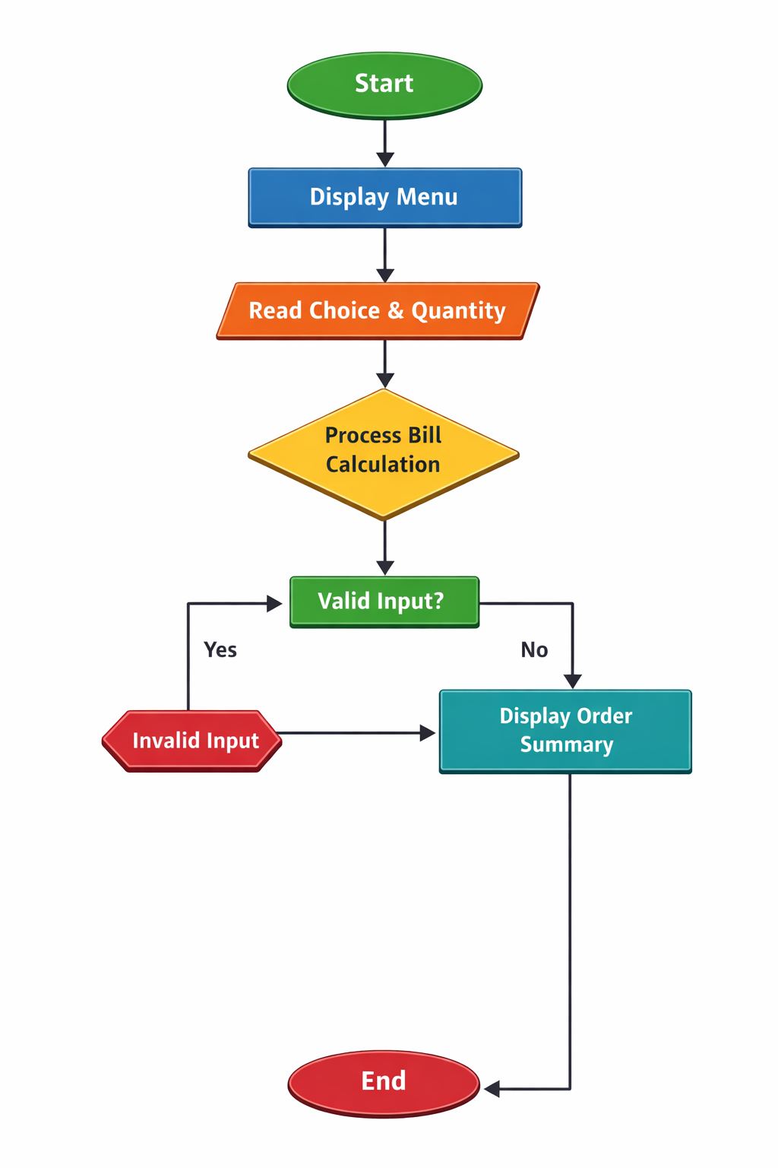

9. Program Code
#include <stdio.h>
int main() {
int choice, qty;
float total = 0;
printf("---------------------------------\n");
printf(" ONLINE SHOPPING SYSTEM\n");
printf("---------------------------------\n");
printf("\nAvailable Products:\n");
printf("1. Mobile Phone - Rs.15000\n");
printf("2. Laptop - Rs.45000\n");
printf("3. Headphones - Rs.2000\n");
printf("4. Smart Watch - Rs.3000\n");
printf("\nEnter product choice (1-4): ");
scanf("%d", &choice);
printf("Enter quantity: ");
scanf("%d", &qty);
switch(choice) {
case 1:
total = qty * 15000;
break;
case 2:
total = qty * 45000;
break;
case 3:
total = qty * 2000;
break;
case 4:
total = qty * 3000;
break;
default:
printf("Invalid choice\n");
return 0;
}
printf("\n-------------------------------\n");
printf("Order Summary\n");
printf("Quantity : %d\n", qty);
printf("Total Bill Amount : Rs. %.2f\n", total);
printf("---------------------------------\n");
printf("Thank you for shopping!\n");
return 0;
}

10. Sample Input / Output

Input
Enter product choice: 1
Enter quantity: 2

Output
Order Summary
Quantity : 2
Total Bill Amount : Rs. 30000.00
Thank you for shopping!

11. Result
The program was executed successfully.
It correctly calculated the total bill amount based on the selected product and quantity.

12. Applications
- Learning basic C programming
- Academic mini projects
- Understanding billing systems
- Beginner software development

13. Conclusion
The Simple E-Commerce System demonstrates core C programming concepts such as input/output operations, conditional logic, and switch-case statements. This project provides a strong foundation for developing more advanced applications.

14. Future Enhancements
- Add multiple product selection
- Implement file handling for order storage
- Add user authentication
- Improve user interface

15. References
- E. Balagurusamy – Programming in ANSI C
- C Programming textbooks
- Online C programming tutorials
- Class notes

